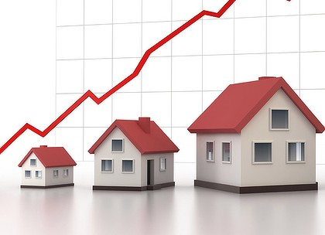

Determinants of Housing Prices

Romaisa Abid

**Introduction**

In the United States, the number one way to build wealth is through home ownership via obtaining a mortgage. As a general standard, an average person typically wants to spend 30 % of his or her income on housing (CNBC). Housing is one of the biggest monthly expenses, and also one that is least flexible. Moreover, there is huge variation between housing prices amongst and within cities and states in the US. This variation arises from several economic, political and social factors. A change in any single factor can create havoc on an individual’s finances. Hence, it is essential to understand these factors, so that individuals/consumers can better predict favorable outcomes over unfavorable ones.

This report attempts to examine economic factors that may be correlated with housing prices in the United States. These include resident population, average annual unemployment rate, median household income, average annual inflation rate, federal funds rate (interest rate), and GDP (growth rate in percentage). Considering the basic economic law of demand and supply, the hypothesis is that as the population continues to increase, there will always be a demand for houses, while the supply side may not be able to catch up. As a result, there will be an increase in housing prices. The data, which was collected from FRED, Central Bureau of Statistics and Statista, represents a 26 year time period from 1990 to 2016.

**Methods**

Data was gathered for median housing prices in the United States, along with six more factors thought to have an influence on the prices. The average housing prices in the United States was also included, to better understand the distribution of prices. The median and mean prices were compared using descriptive statistics. The correlation coefficients, coefficient of determination and covariance were computed for all six independent variables with the median housing prices. From this information, it was concluded that the three most highly correlating factors for housing prices are resident population, federal funds rate and median household income.

A regression analysis for all 6 variables was run to understand which factors most significantly contributed to or correlated with housing prices. Then, the top three variables with the lowest p values ( <=0.005) were noted, where there is a 95% chance of correlation, omitting the possibility of chance. One possible case of an error with the chosen independent variables would occur if these variables were dependent on each other. With a focus on economic factors, it is difficult to have many variables independent of each other as they are often inter-linked indirectly or directly.

**Findings**

**Average Housing Prices vs. Median Housing Prices**

The mean for average housing prices is $242,044, less than the median value of $246,300. The data is skewed to the left (Median > Mean), and the negative kurtosis value indicates a flatter peak, relative to a normal distribution. This can also be observed from the small difference between mean and median values.

In comparison, the mean value for median housing prices is $197,951, greater than the median value of $195,000. The data is positively skewed to the right.

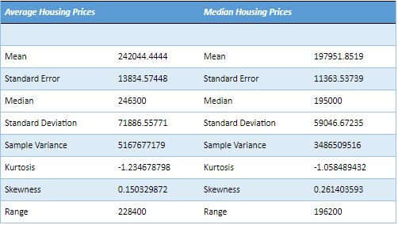

The importance of median housing prices, as opposed to average housing prices, is reinforced when we compare the standard deviations. The standard deviation for median housing prices is $59,046, which is significantly lower than the standard deviation of $71,886, for average housing prices. The higher SD value means that the data is much more spread out, as would be expected from an average-values dataset since it includes extreme outliers. The smaller SD value indicates lesser variability amongst the median-values data set, as would be expected because median values are not as affected by extremes.

While both average and median housing prices are good indicators of price expectations, the median is often more reliable. By taking the mean, extreme outliers are accounted for and can significantly skew data. This is possible when it comes to housing prices because some states and cities have areas with extraordinarily high and low prices (good/bad location, nearby attractions, etc), compared to the standard prices at that time of the area.

*Figure 1.1 Average Housing Prices and Median Housing Prices in the United States*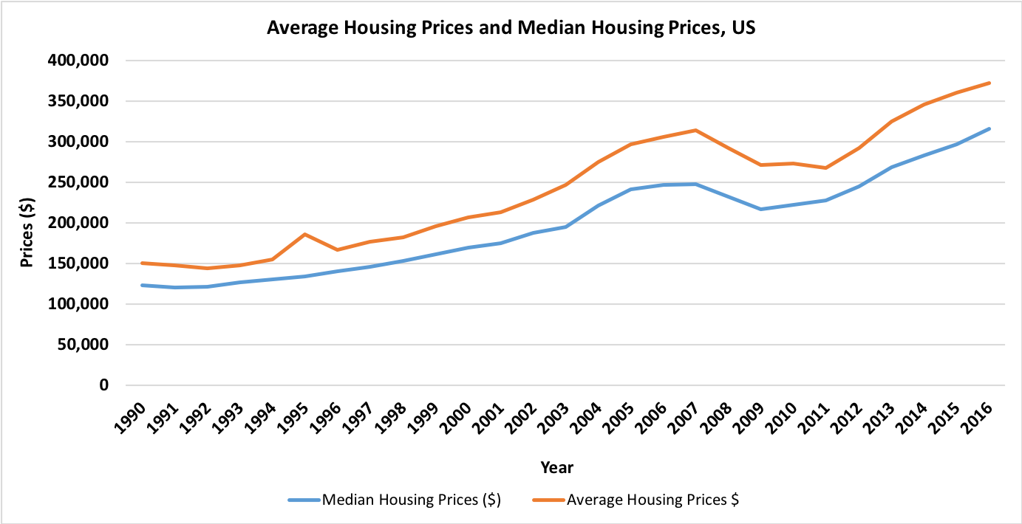

By looking at a yearly basis, the dollar amount differences between the average and median housing prices both follow an upward trend (excluding the great recession time period). With a smaller variability and better representation of prices, it is believed that the information and findings would be more accurate using the median housing prices. To further analyze the data, a mixture of scatter plot, line, and combination graphs were used to observe the fullest dimensions of the relations between the independent and dependent variables. Below are the charts for some of the determinants that were analyzed.

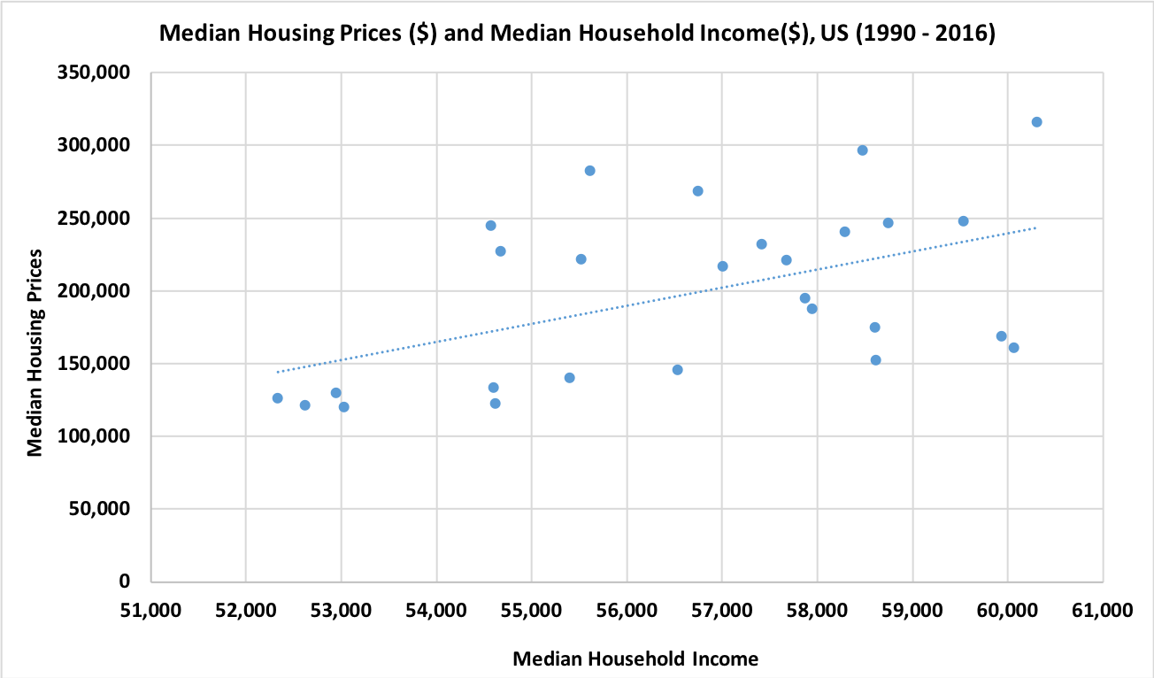

*Figure 2.1 Comparison of Median Housing Prices and Median Household Income in the United States*

When looking at the median housing prices and median household income, it is apparent that there is a positive relationship between the two. This means that when one increases, the other will also increase. In the United States, a home can be considered a normal good because it is expected that families own a home. Due to the nature of this good, an increase in income leads to an increase in the consumption of normal goods. This makes sense because when income rises, consumers are able to purchase more expensive commodities (like houses).

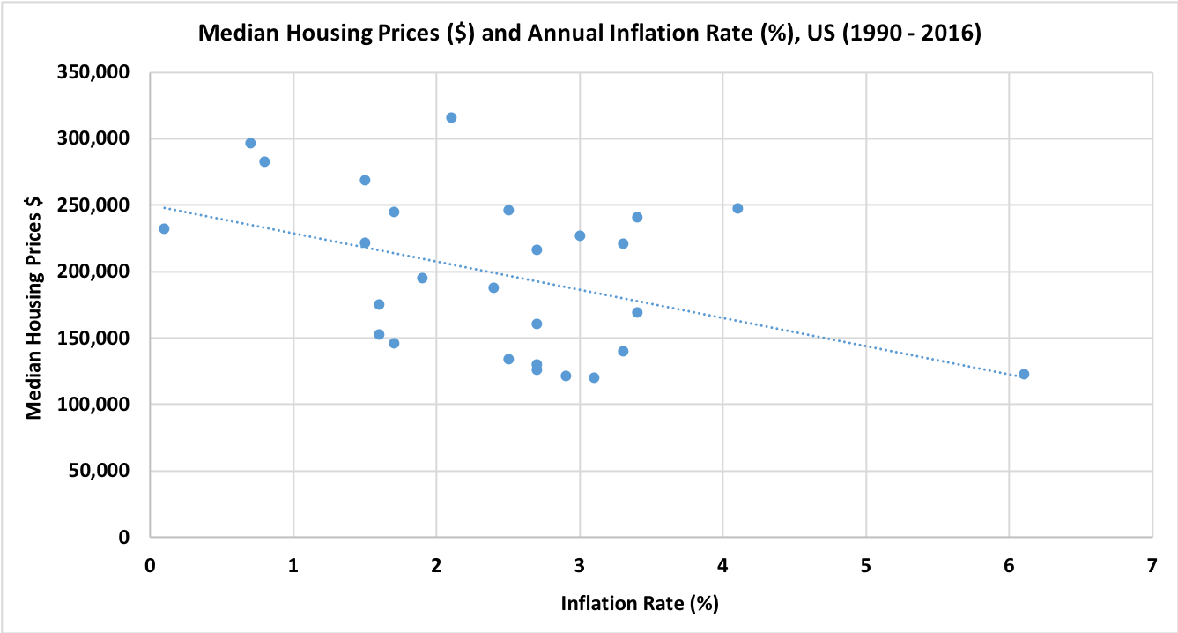

*Figure 2.2 Comparison of Median Housing Prices and Annual Inflation Rate in the United States*

By focusing on the median housing prices and the annual inflation rate, there is a clear negative relationship between the two variables. Again, as one variable rises or falls, the other will follow in an opposing manner. Increasing the money supply causes inflation and housing prices to rise. This graph shows that as the median housing price increases, the inflation rate tends to be lower. During inflation, there is a general increase in prices. While we would expect housing prices to increase when inflation occurs, the results showed the opposite. This happens when the economy, similar to that of the United States, is strong enough to not be negatively affected by inflation. Strong economies adjust inflation prices with higher incomes, and hence people can afford higher housing prices.

*Figure 2.3 Comparison of Median Housing Prices and Resident Population in the United States*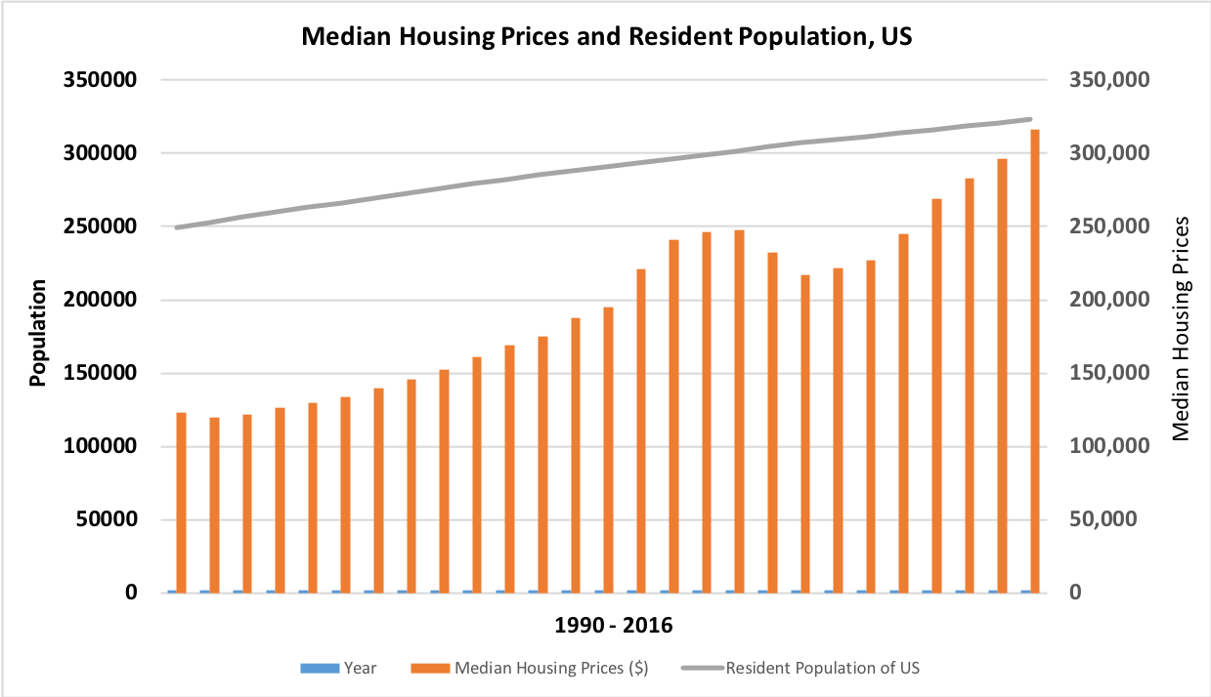

By observing the median housing prices and population growth, it can be seen that the two variables share a positive relationship. Both are seen generally increasing with one another from 1990 to 2016. The brief downward trend in housing prices reflects the great recession period (December 2007- June 2009), during which decreased housing prices would be expected. Other than that, as the population continues to increase, the demand for housing would be expected to increase. It can be added that population increases could also owe to factors like immigration, and hence a higher demand for houses and subsequent higher prices are observed. In another perspective, it can be said that when housing availability is adequate, it can, in turn, promote family expansions, thereby increasing population numbers.

After comparing the median housing prices with the federal funds rate, the relationship between the two seems to be negative. Again, when two variables are negatively related they move in opposite directions. When interest rates increase, fewer consumers are willing and able to purchase houses. This usually happens because obtaining bank loans for a mortgage payment with higher interest rates tends to lead the consumer into accumulating a greater amount of debt. When the rates are high, consumers exit the market in hopes of the expected values to lower in the future (less demand = lower prices). However, when interest rates are low, people would be more willing to buy houses. This demand would go on to increase housing prices.

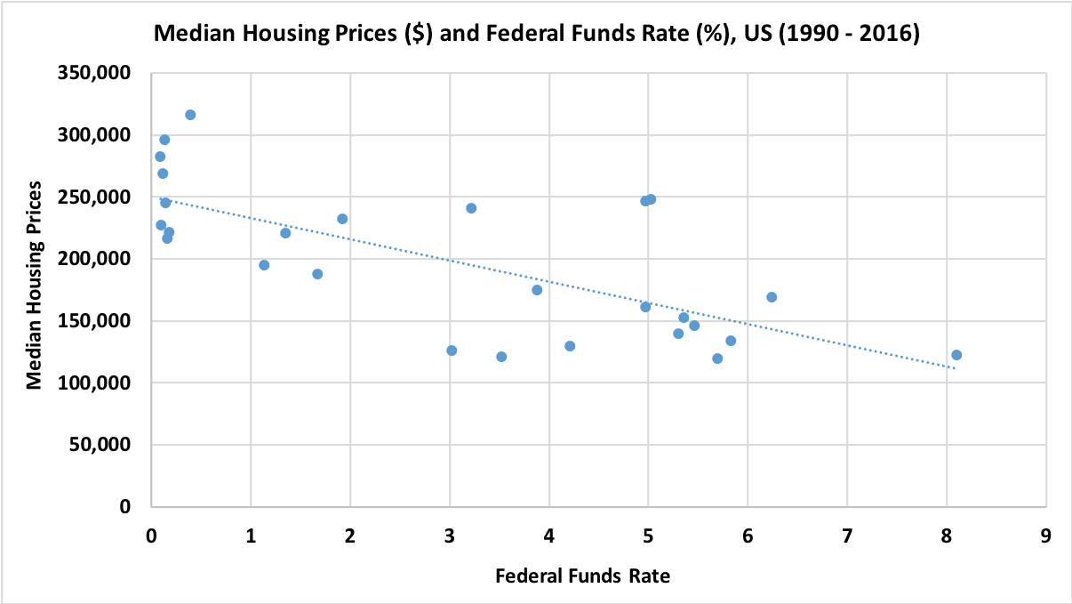

*Figure 2.4 Comparison of Median Housing Prices and Federal Funds Rate in the United States*

**Regression Analysis, Equations, and Correlative Statistics**

The regression line allows us to understand how well we can predict the value of housing prices from the six independent variables. The following equations were obtained:

Multiple Regression Equation:

Median Housing Price = -201381.2768 + 2.9725 (Resident Population) + (-3402.507) Fed Funds Rate + (-6.4485) Median Household Income + 8461.579 (Inflation Rate) + (-2790.310) GDP Rate + (-16185.54) Unemployment Rate.

Simple Linear Equation:

Median Housing price = 2.5195(Resident Population) - 530303

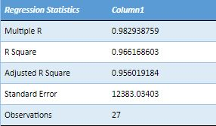

Regression analysis is a good way of assessing correlations because it keeps other variables constant while assessing the effect of a single variable at a time. The coefficients of the independent variables allow to estimate the size of their effect on housing prices, with the sign indicating the direction of the effect. For example, from the table, we can see the unemployment rate to be highly negatively correlated (-16185.54) to median housing prices. This is possible since unemployment and high incomes can exist, and high income means people have more to spend on expensive commodities like housing. So the demand maintains the prices.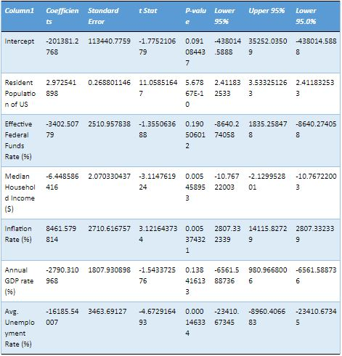

The regression analysis shows that the six variables together explain around 96% of the variance in housing prices. From the analysis of correlation determinants, it was seen that 91.5 % of the variance in housing prices can be explained by the variance in the resident population of the US. On the contrary, only 0.52% of the variance in housing prices could be explained by the average unemployment rates. It also had a correlation coefficient of just 0.072, showing the weakest correlation with housing prices. 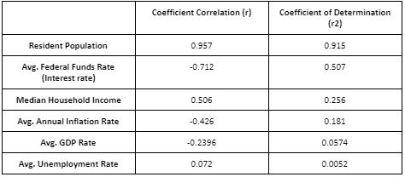

The three most strongly correlated variables were resident population, average federal funds rate and median household income. With values of 0.957 (strong, positive linear relationship), -0.712 (strong, negative linear relationship) and 0.506 (moderate positive relationship) respectively, these factors demonstrated the strongest correlation with housing prices, amongst others.

The average inflation rate accounted for approximately 18 percent of the variance in housing prices. With a correlation coefficient of -0.426, it demonstrated a moderate, negative relationship.

The average GDP rate accounted for 5.74 percent of the variance in housing prices. It had a correlation coefficient of -0.2396, which is a weak, indirect correlation with housing prices.

The p-values for the resident population, inflation rate, and household income confirm their statistical significance in terms of understanding the outcome of housing prices. These values are 5.67867E - 10, 0.0053, 0.0054 respectively, in line with the chosen significance level. This information favors the initial hypothesis and allows us to conclude that changes in these variables are associated with changes in housing prices.

On the other hand, the p values for GDP rate and federal funds rate are well above the p level of significance, as can be seen from the table. To see the federal funds rate in this category was surprising because it had a strong correlation coefficient, and hence a lower p-value was expected. This indicates to us that our data set is not large enough and does not have enough evidence to conclude its correlation with housing prices.

**Conclusion**

In line with the hypothesis, the results showed a very high correlation between population and housing prices. The highest correlation coefficient was observed for the resident population (0.957). The p-value was also very small to support its significance and allow the conclusion that the prediction was not due to chance alone. This agrees with the law of supply and demand. With an increasing number of people, the demand for housing will increase. An increase in demand is usually followed by an increase in prices based on the universal laws of economics. The federal funds rate was surprisingly different from our expectations (as mentioned above). It is assumed that this was because the data sample was not large enough.

It must not be forgotten that correlation does not equal causation. So while some variables have shown strong correlations over others, they are only to the extent of association.